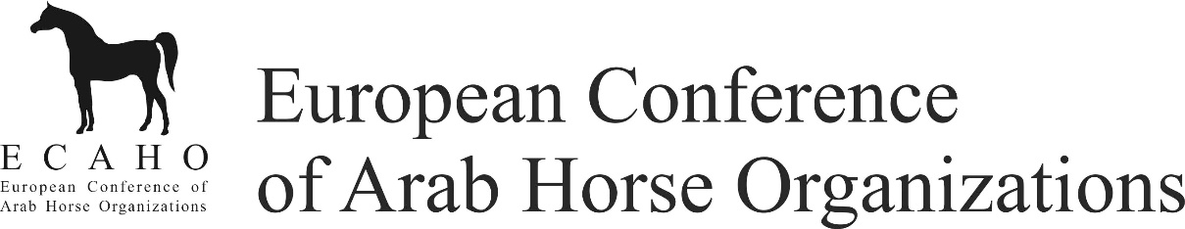

ECAHO Breeders´ Fund - PAYMENT CONFIRMATION

Event:
Date:
Organizer:
Amount: 200 € per horse
Payment method: bank transfer to the horse owner by show organizer

By signing of this document I confirm that:
- I am the legitimate owner of the below mentioned horse and account.
- I am responsible for complying with all income tax laws applicable in my country of residence.
- I agree to the Privacy Policy as published on ECAHO's website (www.ecaho.org).

Class | Ranking | Horse no. | Horse name | Horse and account owner’s name only | Horse and account owner’s signature only
Horse and account owner’s bank account / IBAN: |  |  |  | SWIFT:
Class | Ranking | Horse no. | Horse name | Horse and account owner’s name only | Horse and account owner’s signature only
Horse and account owner’s bank account / IBAN: |  |  |  | SWIFT:
Class | Ranking | Horse no. | Horse name | Horse and account owner’s name only | Horse and account owner’s signature only
Horse and account owner’s bank account / IBAN: |  |  |  | SWIFT:

Total amount to be paid by ECAHO: € _____________________

Date:

Signature

