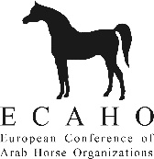
Probationer Report by Senior DC
Name of Probationer DC: Date:
Name of the Show:
Venue: Country:
Category of show: Number of horses presented:
Address of probationer (incl. phone/fax/e-mail):

General basic knowledge (experience with horses and shows):

Understanding and use of Blue Book:

General attitude and interaction with participants:

Comments:

Name of Senior DC (please print): Date:
Signature of Senior DC:
To be sent immediately after the show to the Executive Secretary of ECAHO:
ECAHO Office, Zuzana Slavíková, Na Blatech 242, CZ-27711 Libis, Czech Republic
Phone +420 602 876 396, e-mail: zuzana.slavikova@ecaho.org

